Senior Project Proposal

iPad Game

The game is a 2D scroller that has the player control a ship or shape on an iDevice (iPad or iPhone). Control is done via touch so it is much more interactive.

The player does the usual space shooter related things like gather points, weapons while trying to avoid and destroy enemies.

To avoid the usual space shooter cliché, the user does not shoot at targets but rather an orbiting weapon revolves around the player’s ship. The player has to destroy enemies by getting close to enemies with their revolving weapon but also avoid being hit by enemy units.

Enemy units will take certain shapes and this will dictate their movement path. For example: a triangle shaped enemy will travel a triangular path around the screen.

Gameplay similar to Tyrian

Art, look and feel like Geometry Wars.

Base Features

* At least 5 levels
* Level editor for player level creation
* Boss fights
* Upgrade Store for user progression in game
* Deployment to App Store for feedback and beta testing

Possible Features

* Multiplayer co-op and player vs. player
* In app purchases (virtual goods)
* Level sharing

Technologies Needed

* iOS SDK with Xcode IDE
* Cocos2D and Box2D

Screenshot of Geometry Wars

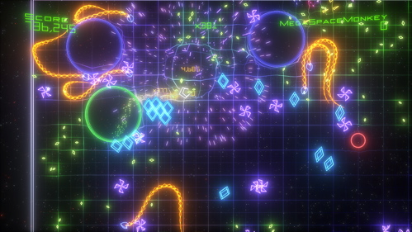

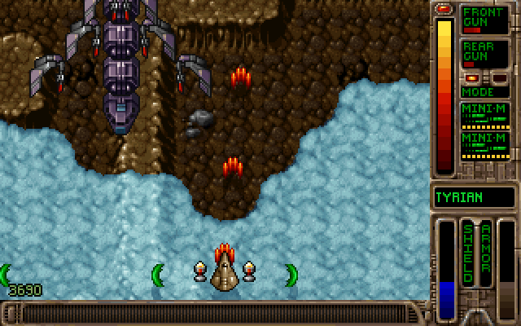

Screenshot of Tyrian

Detailed Plan

Winter 2012

January 3

* Comparative analysis of existing iPad games and features.

January 9

* Player controls, abilities, animations

January 16

* Enemy units abilities, animations

January 23

* Create test level and design to be extendable with Level editor.

January 30

* Play test and refactoring
* Time for bug fixing and other issues / features

February 6

* Particle effects

February 13

* Implement unit models and environment.

February 20

* Lighting and shading

February 27

* Audio and sound effects

March 5

* Design and create additional levels.

March 12

* Create tutorial

March 19

* Play testable build complete.
* Play test and refactoring.

Spring 2012 – may change

March 26

* Level Editor development.

April 2

* Level Editor development.

April 9

* Multiplayer

April 16

* Multiplayer and additional features

April 23

* Additional time for bug fixing and other issues

April 30

* Play test and refactoring

May 7

* Play test and refactoring

May 14

* App Optimizations

May 21

* Senior Project Write up

May 28

* Senior Project Write up

June 4

* Initial release to App Store